User Manual

Model: NEI-DVR695

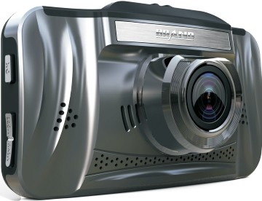

Preface
Thank you for purchasing the vehicle safety series product of High-definition
car camera recorder. This product is designed for traffic accident, while is difficult to obtain evidence. It is also suitable to meet the needs of other occasions.

This product is the first car recorder combined with the dual system of using a touch and entity key, with the function of wide visual Angle, clear image. It has industry leading design with high-definition camera, super low illumination, ultra wide Angle lens, the G- Sensor features.

This user manual is convenience for you to learn operation notice,installation, precautions and specifications. Please read this manual carefully before use and fully understand. Please take good care of this manual. We hope our products can meet your requirements and serve you all the time.
This product complies with FCC&CE authority certification, ensure customers
the use of security.

Product Features :
1. Super-wide 300W pixels high and low intensity of illumination, 170
degrees ultra wide angle lens
2. HD 1080p video
3. External GPS module to record the track of driving (optional)
4. H. 264 compression format, 1080P/ 720P video output, VGA 30 fps
5. 3.0 inch high resolution display, support TV, HDMI output
6. Touch and entity key integration, two-way choice, more convenient manipulation
7. One-key emergency HOLD video button
8. Built in G-Sensor, can be automatically forced to save the video before
and after impact , which is convenient to obtain evidence.
9. Truly seamless video, don't leave out any important data
10. Super strong 5 mm white light photography LED.

Installation:
Press the power button to turn on the recorder, set the time/date and functions. If do not set separately, all functions, time/date would be followed the factory default values)

A. Wipe clean the windshield, Put suction mount against the glass in a suitable position, Press the suction bracket handle to ensure that the bracket is well fixed.
B. Check screen images, adjust the machine on the shooting Angle.

Use the car charger to connect the power.

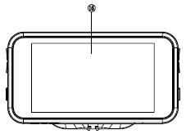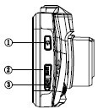Product structure:

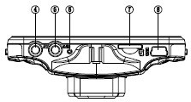
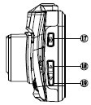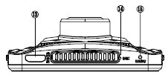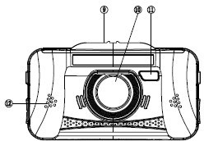

⑴Pow er button ⑵M O D E button ⑶M EN U button ⑷T V interface ⑸G PS socket
⑹indicator light ⑺TF card slot ⑻U SB Slot ⑼Bracket slot ⑽ lens ⑾ W hite
light ⑿Speaker slot ⒀H D M I interface ⒁M IC ⒂R ESET ⒃3.0 Display ⒄OK
button ⒅up button ⒆ down button

Power supply:
1. Built-in 200mAH rechargeable polymer lithium battery，can maintain short
time Video or operation .
2. Use car charger to insert into the cigarette lighter , Camera will switch on and begin recording automatically when start the car. Shut down automatically and saved the data after power off.
3. Include one piece of charging line for DIY enthusiasts，can connect the car
roof light to get the power and avoid messy wiring. Notice: In this power
mode, the camera will not automatically power off when car engine shutdown.

Operating instructions:

1. Insert TF Card into card slot：Suggest CLASS6 or above (Pleas format the card for the first time to use)
2. Short press the power button to switch it on, long press the button to turn it off. In the video mode, short press the power button as a shortcut
to control night-vision light.
3. Menu selection：In standby mode，Enter the system menu interface and
choose the
option , press OK button to confirm.
4. Mode selection: System default to video mode, short press mode key
can switch between pictures, playback and video recording mode

5. Video：in video mode, short press OK button to start recording , press again to stop. If use the car charger power supply, Video recording will switch on automatically when the car turns on.
6. Photo: In picture mode, short press OK button to take photos
7. Playback mode: in the preview mode, can check the saved photos and videos, short press up/down button to choose the required file, Long press can be fast backward /fast forward operation
8. Sound setting: In video mode, short press the menu button as a shortcut control for sound recording. In sound closed mode, Will only video without voice.
9. Emergency video LOCK: In video mode, short press MODE button to
start the emergency video function.
10. Motion detection: In video standby mode, long press OK button can enter the motion detecting video function.

Specification:
This product is with high technology optical imaging device. It is recommend not to place it in low temperature condition for a long time. Otherwise the water vapor produced by the heat when camera switch on may adversely affect on the machine.
The camera is built-in with high capacity lithium polymer battery. It can be recharged when connect to the computer or car charger. In the process of charging the red indicator light will be on and will be off after finish.

Image sensor | 300W Pixel CMOS sensor
View angle | 170 degree ultra wide angle
LED screen | 3.0 inches TFT LCD
HDMI output | HDMI interface
USB output | USB2.0
TV output | NTSC、PAL
Video format | MOV
Video resolution | 1920x1080; 1280x720;848x480；640*480
Photo format | JPG
Photo resolution | 12M;8M;5M;3M
Compression format | H.264
Audio | Microphone and speaker Equipped
TF card | Support Max.32G
Language | Support multi-language
Battery | 5V 200mA,polymer Li-ion battery
Work Temperature | -10~600C

