Direction Recognition
Curtain Passive Infrared Motion Detector

This product has a beautiful and smooth appearance and can be installed on the ceiling or wall. Suitable for use in security measures such as balconies, windows, doors, corridors, etc., Microprocessor control is adopted, ensuring the reliability of the product from a design perspective.

Wiring diagram

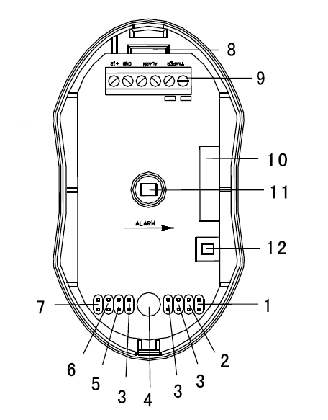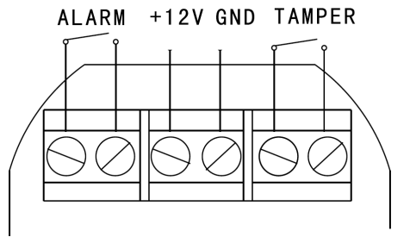
+12V: DC power positive
GND: DC power negative
ALARM: relay output terminal
TAMPER: tamper switch output terminal

- NC jumper 2.NO jumper 3.return timer jumper 4.LED indicator light 5. LED jumper 6. TEST jumper 7. USE jumper 8. outlet 9. terminal 10. relay 11. dual element infrared sensor 12. tamper switch

Technical Parameter
Working voltage | DC 12V (applicable range DC9-6V)
Current consumption | Static state: ≤ 20mA, Alarm state: ≤ 30mA ,Delay state: ≤ 30mA
Self check period | 120seconds
Alarm duration | 5seconds
Sensor | low noise dual element pyroelectric infrared sensor
Operating temperature | -10 ℃~50 ℃
Installation method | wall mounted
Installation height | About 2meters
Detection angle | 15°
Detection distance | 8meters
Detectable speed | 0.3~3m/s
LED | YES or No optional
Timer selection | 1min,5mins,10mins optional
Terminal port | ALARM, GND,+12V, TAMPER
Relay output | Normally closed/normally open optional, contact capacity 28VDG, 80mA
Tamper switch | Normally closed without voltage output, contact capacity 28VDC, 100mA

Detection Range
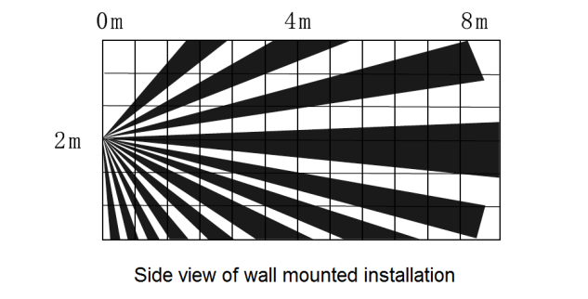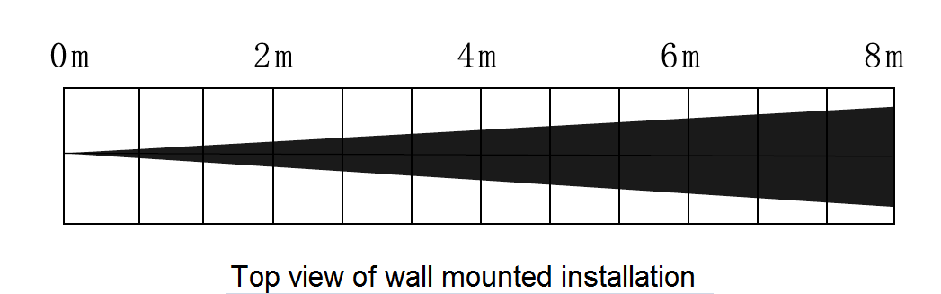

Installation of the product
1. The detector should be installed in a location that allows it to sense foreign invasions, making it possible for intruders to cross the detection area.
2. The installation location should avoid being close to air conditioners, fans, refrigerators, ovens, and objects that can cause rapid temperature changes. At the same time, direct sunlight should be avoided on the detector.
3. There should be no object in front of the detector lens, otherwise it will affect the detection effect.
4. During installation, attention should be paid to pointing the arrow labeled "ALARM" on the circuit board indoors, and the indicator light should be located below the lens.

Product testing
1. When conducting a walking test, the TEST jumper should be selected to turn off the detector return timer and put the detector in the testing state.
2. Connect the wires according to the wiring diagram, and then connect the 12V DC power supply. The red LED and green LED flash alternately, and the detector starts self checking for about 120 seconds.
3. After completing the self check and waiting for 5 seconds, the tester enters the room from outside. The red LED indicator light of the detector lights up for 5 seconds, and the alarm relay acts.
4. After the red LED indicator light goes out for 5 seconds, the tester travels from indoor to outdoor. The green LED indicator light of the detector lights up, and the alarm relay does not act.

Product Use
- During normal use, please select USE jumper to activate the detector return timer. The return timer has three delay times: 1 minute, 5 minutes, and 10 minutes for customers to choose from.
- When the return delay time of the return timer is set, if the detector's invasion direction or exit direction is triggered, the red or green LED indicator light will light up for 5 seconds, and the green LED indicator light will flash within the set return delay time. During the return delay time, the detector will not be triggered from indoor to outdoor or from outdoor to indoor.
- LED 0N/0FF sets whether the LED indicator light has an indication, and does not affect the normal operation of the detector.
- NC/NO is the output relay jumper, used to set the alarm output state. Different output states can be selected according to the specifications of different types of hosts. NC is selected as the normally closed state, and NO is selected as the normally open state. Factory default is NC normally closed state.

Note:
- Please install and use the passive infrared detector correctly according to the instructions. Do not touch the surface of the sensor to avoid affecting the sensitivity of the detector. If you need to clean the sensor, please disconnect the power and wipe it with a soft cloth dipped in a little alcohol;
- Avoid using in environments with significant temperature changes.

