4K 8MP IR Dome PoE IP Camera H.265 Onvif
Model NO.:MEGA 83 EV

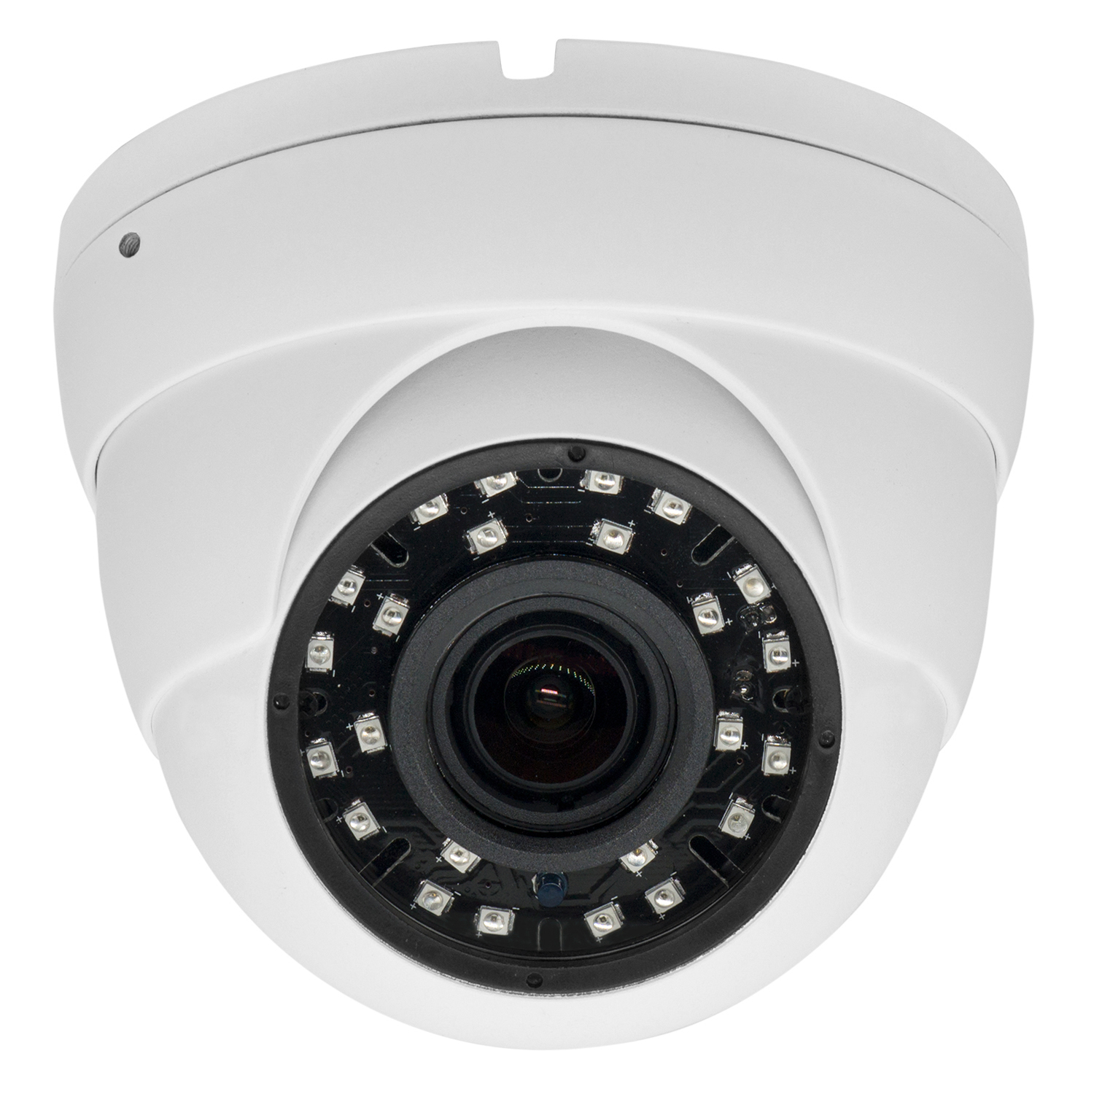

Key Features:
Face detection,Humanoid detection, Vehicle detection,and other smart functions;
4K 8MP Black light illumination resolution 3840*2160@16fps, clear and fine images;
2.8-12mm motorized autofocus vari-focal lens.
Adopted 14mil SMD IR led lamp, up to 25-30m IR distance.
Built-in 1ch microphone, built-in PoE/12V 2A power
Support 2D/3D noise reduction, digital wide dynamic;
Advanced H.265AI/H.265+(Compatible with H.265/H.264) video compression, Super low rate, high definition quality of image;
Onvif protocol, support the third party NVR, Support various mobile monitoring(iPhone, Android);
Provide web, CMS, center platform management software XMeye Pro,provide SDK development
Support cloud technology, easy to achieve network penetration, for in-line and alarm information pushed.
Professional anti-lightning, conform to GB/T17626.5 and IEC61000-4-5.

Technical Parameter:
Model Number | Mega 83 EV
Camera
Image CMOS Sensor | 8MP 1/2.8" SONY IMX415 Black light illumination Progressive CMOS sensor
DSP | Embedded RTOS,dual-core 32bit DSP(NT98566),pure hard compression ,watch dog
Resolution | 8MP Pixel
Effective Pixels | 3840*2160@16fps
Electronic Shutter | 1/50-1/10000Sec
Motion Detection | Support
Low illumination | color 0.0001Lux@F1.2, black/white 0.0001Lux@F1.2CMOS
Sync System | External
Privacy Masking | Support, Up to 4 areas
S/N Ratio | ≥52dB
White Balance | Auto/Manual
Gain Control | Auto/Manual
Digital Noise Reduction | Support 2D/3D
Wide Dynamic Range | Digital WDR
Recording Mode | NVR/CMS/Web
Video and Audio
Video Compression | H.265AI(Compatible with H.265/H.264), support dual stream, AVI;0.1M~8Mpbs variable;1~30f/s variable
Video Output | Main stream: 8MP 3840*2160@16fps; 5MP 2880*1616@25fps; 4MP 2560*1440@25fps; 2MP 1920*1080@25fps; sub-stream: 800*448@25fps
Audio Processing | G.711,support bidrectional talk,audio&video synchronization
Audio input/output | Built-in 1ch High Sensitive Microphone
Lens
Focal Length | 2.8-12mm Motorized Autofocus Varifocal Lens
Auto Iris Support | N/A
Night Vision
Infrared LED | 24pcs SMD IR LED, 25-30M IR range
Day & Night | Support IR cut
Network
Ethernet | RJ-45 (10/100Base-T)1*RJ45 10/100M adaptive Ethernet port
Network Protocol | support RTSP/FTP/PPPOE/DHCP/DDNS/NTP/UPnP etc
Smart Phone | Support iPhone, iPad, Android and Windows
Browser | Support IE, Chrome, Firefox, Safari
Software | Support App(iOS, Android), Window CMS software
Intelligence analysis | Face detection, Humanoid detection, Vehicle detection,and supports customization of other smart functions
General
Power | DC12V/2A input, ; Built-in POE 48V1A power supply
Power consumption | Led lamp on:≤10W
Housing | Al-Alloy Case, White Color Housing
Working Temperature | -20℃～65℃
Weatherproof Std. | Support Waterproof, IP66
Dimension | Size: 119(W) x95(H) mm
Weight | 0.72 Kg

