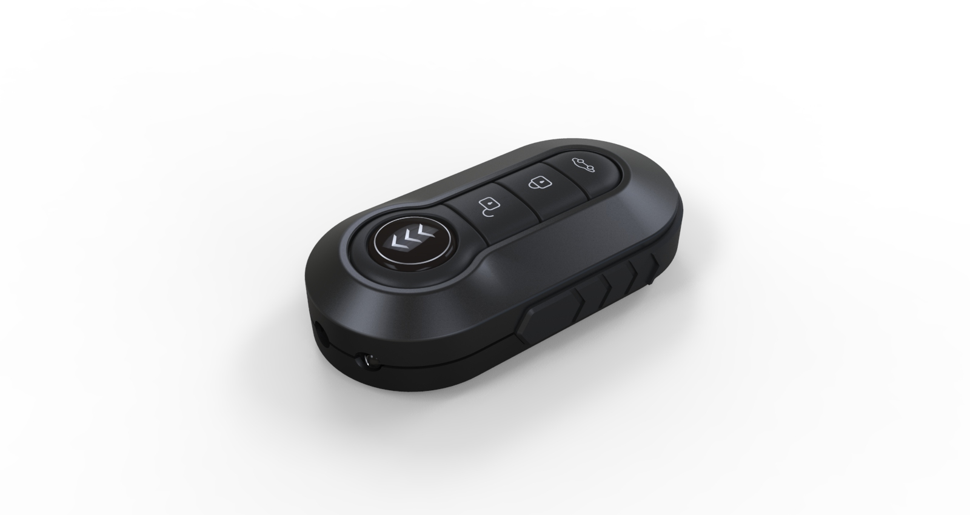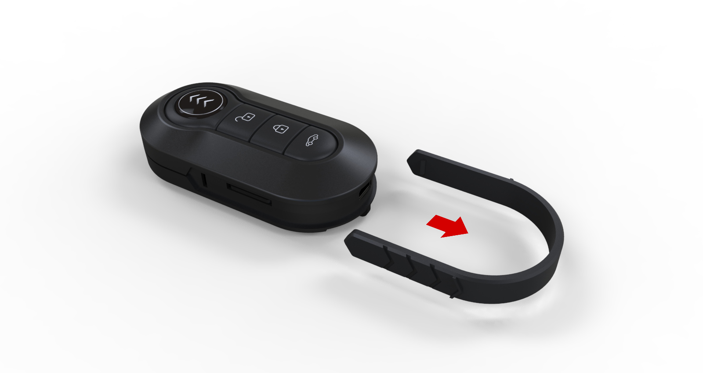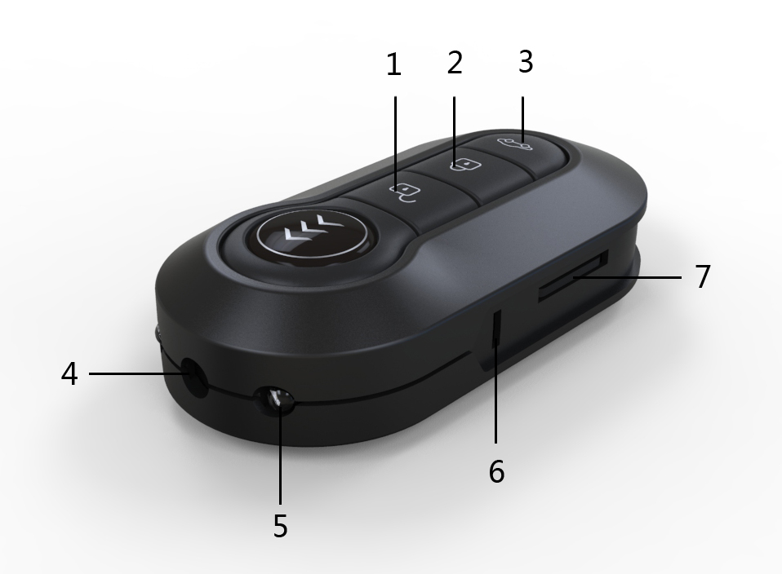
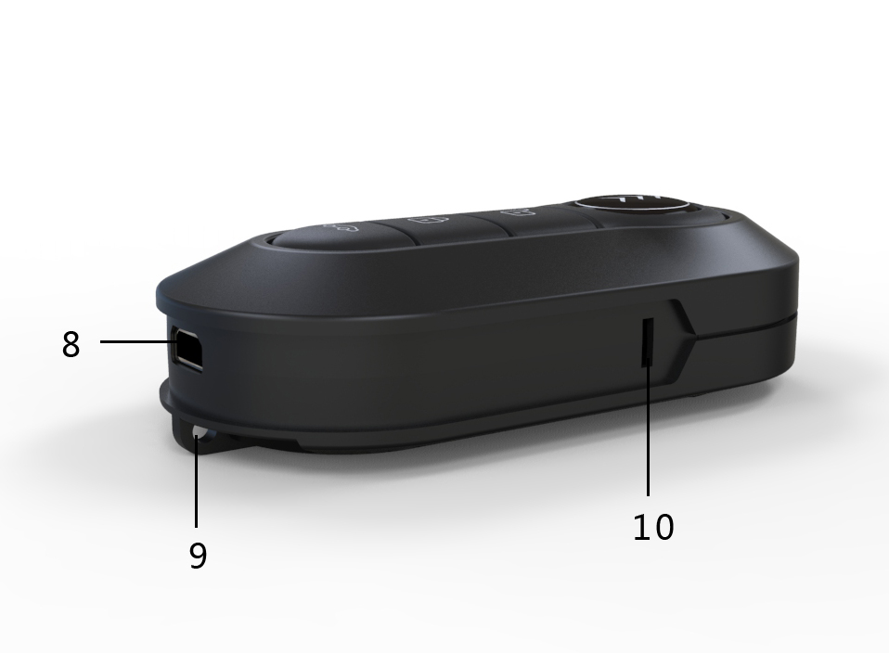 1, turn off key (key) confirmation 2, mode button 3, night vision key light on 4, 5, night-vision camera lights
6, block slice button hole, 7, 8, 9 USB, TF card lanyard hole 10, indicator light observation hole
This product is the world's first reply to the user command, high-definition infrared camera high-tech remote control. Perfect embodiment machine intelligence, reply the operator of the orders in a timely manner. Auxiliary hidden light function. When using the product please in strict accordance with the instructions to guide to use.
A, product characteristics
function operation,λ &vibra activation. Human-computer interaction, perfect contact.
metal shell, well-made. Hidden lights.λ
night vision function, and support lowλ illumination.
support 1920 * 1080 video 30 frames perλ second.
machine cabinet, with 260 ma highλ capacity battery.
Second, the product introduction
Charging:
Native built-in rechargeable lithium battery, first time using this machine, please charge, when the machine start charging power supply is connected, there will be vibration. The machine can charge the battery through the following ways:
1) to connect the computer charging, using the USB cable connected to the computer, can be charged.
2), with the charger, use the USB cable connected to the charger, the charger plug in electricity socket again, can be charged.
When charging, the blue lights charging, red light flash machine fully charged when the red light bright.
&vibra activation status:
Each command from you. When the machine starts to execute the command, will give you a reply.
1, the on/off machine, the machine vibration tip 3 seconds.
2, video: video standby mode, began to video, save the video. Machine &vibra activation time,
3 and take photos: photo standby mode and take photos. Machine &vibra activation time,
4, recording separately: recording standby mode, start recording, preservation. Machine &vibra activation time,
5, mobile detection: motion detecting standby mode, began to video, manual save video. Machine &vibra activation time,
6, night lights, night lamp open, closed, two consecutive vibration machine.
Machine status indicator light:
1, the battery when the battery is low, the machine will quickly flashing red lights and turn it off. The current recording file will be automatically saved.
2, memory card is full, the machine blue light fast scintillation and shut down, the current recording file will be automatically saved.
Machines not loaded into memory card, 3, red and blue light rapid flashing at the same time, and then 10 seconds automatically power off.
4, motion detecting video, any mode standby state, such as the machine has been idle, without any operation. The machine will automatically power off after 1 minute.
5, video standby mode, long bright blue lights red light. Video work state, blue lights red light flashing regularly.
6 and take photos on standby mode, long bright blue light red light is out. Photographed working status, the red light out, take a photo blue lights flashing.
7, recording standby mode, at the same time long red and blue lights on. The recording work state, blue light long bright red light flashing regularly.
8 and motion detecting video mode, the red light flashing blue lights normally on. Motion detecting video work status, red and blue lights flashing at the same time.
8, night-vision light open, yellow lights. The night vision function closed and yellow lights.
video
Long press on/off button 3 seconds after the boot. Red and blue lights bright at the same time, when the phone is switched on and the blue lights, red light. When the machine into the video recording standby mode. Click the ok button one at this time. The red light flashing, regularly machine start working video. Machine video, click the ok button, the video files automatically saved. Back to the video standby machine. Machine started video work, such as no video is stopped manually. Machines will have been working video and an AVI files are stored in the every 5 minutes. Until the memory card is full or machine no electricity will automatically save the recorded files, and to turn it off.
Taking pictures
Boot into the video recording standby mode. Click on a mode button, the red light, blue, light long on machine into standby mode taking pictures. At this point need to take photos with a single click the confirm button, blue lights flashing said photographed one at a time. Take pictures after the machine back to standby mode taking pictures.
The recording
Boot into the video recording standby mode. Click a mode button, the red light, blue light long on, said into pictures on standby mode, click the mode button, once again at the same time long red and blue lights on. When the machine into separate recording standby mode. At this time with a single click the ok button, the blue lights long slow flash a red light. Start the recording work machine. Recording the working status, click the ok button again to stop the recording. Machine back to the recording standby mode. The recording work status, such as no manually stop the recording, the machine would have been recording work. And a recording file automatically save every 15 minutes. Until the card is full or machine no electricity will automatically save the recording file, and to turn it off.
Motion detecting
Machine when recording standby mode, click a model was built, the red light flashing blue lights long, said the machine into standby mode motion detecting video. When camera as observed with moving objects, machine start work video alternating red and blue lights flashing. Working status need to stop the video, the video with a single click on the confirmation. Video files are automatically saved, and at the same time machine back to motion detecting video standby mode. In motion detecting video work status, such as no video is stopped manually. Video will always work, and every 5 minute hand save a AVI video files. Until the card is full or batteries, the machine will save the current recording file and turn it off.
Charging video
The charger connected power supply, charger via cable connection. Machines, turning on the power supply when the red light flashing, at this moment is recharge machine. Machines charging time hold the mode key, long red light charging machine into the video mode, the machine automatically turned on and video into standby mode. At this moment can operate machine as normal operation. Machine can realize video, pictures, recording and motion detecting, etc. Such as have no long press machine model, machine after turning on the power supply will be directly recharge machine. Charging indicator light blue lights red light flash to the machine, the machine long charged when the red light bright.
Night vision function of opening and closing
After the machine starts, in any mode and state. If need to open the night vision function, only need to long press night-vision light on the key. When light yellow lights up the night vision function, said the night vision function has been opened. Night-vision light open mode, long press night-vision light night vision function will be closed down key. Night vision function indicator light yellow lights, said the night vision function has been closed.
PC camera function:
After installation CD in the DRIVER file, can be used as PC camera, in the boot state, long press and hold the MODE button to insert the USB, after connect with computer in the "my computer" icon will appear in the camera, then loosen the MODE button. Click the camera icon in a computer can be normal use.
TV OUT:
Through the cable machine connected to the TV, after switch on TV screen can be a real screen machine use. At this moment can be normal operation machine video, pictures, recording and motion detecting, etc. Recording the screen will be displayed on the TV screen.
Shutdown: after the machine starts, in any function mode, the need to turn it off. As long as the long press the switch machine key 3 seconds, light red and blue lights, said to turn it off. Such as machine shut down, when he worked in video or audio recorded the current file will be automatically saved.
Reset: when the machine because of illegal operation or other unknown reason, cause the machine doesn't work. The machine can be reset, press mode key don't let go, click again on/off button. Light is put out to reset. Can use normal boot after reset.
Time to modify and Settings
Specific usage is as follows:
Computer via a USB connection USB mode, the attachment CD TIMERSET. TXT text file according to the format after the modification time, copy the TXT file to the root directory of the U disk mode. Then remove the USB cable, new open the machine again. The RTC time watermark is written into the machine, don't need time watermark is also operating mode.
1:20 110908142432 Y watermark (with time)
Watermark show "110908142432 N (no time)
Waste treatment: please pay attention to environmental protection, do not throw this product. Forbid throwing this product in the fire, so as to avoid explosion.
Related parameters
Project related parameters
AVI video format
Video coding M - JPEG
The video resolution 1920 * 1080
30 FPS video frame rate
Photo 12 million pixels
Image format JPG
Image ratio 4:3
PC camera resolution of 320 * 240
Player software operating system or bring the mainstream video player software
Support system Windows me / 2000 / xp / 2003 / vista; Mac OS. Linux;
Working time about 100 minutes
Charging voltage DC 5 v
8 pin Mini USB interface type
Storage support TF card

